**Project Log**

**Problem Statement 8:**

**Scenario**:

Local businesses are the backbone of many communities, offering unique products and services that large chains and online retailers often can't provide. However, these small businesses frequently struggle to compete due to limited resources, lower visibility, and challenges in managing day-to-day operations. For example, a local bakery may find it difficult to reach new customers or manage its inventory effectively, while a neighbourhood bookstore might struggle with promoting events or special offers. Moreover, local consumers may be unaware of the variety and quality of products available right in their neighbourhoods, leading them to shop at larger, more well-known stores instead. The ongoing challenges posed by economic downturns and changing consumer habits have made it even more critical for local businesses to find innovative ways to attract and retain customers.

|  |  |  |  |
| --- | --- | --- | --- |
| **Group No.** | **Learner 1** | **Learner 2** | **Project Number** |
| 8 | Yukthashree K H | Pratham Singh | 8 |

* **April 03, 2025**

**Agenda :** Discussion on Introduction, Project scope and Functional Requirements of the project.

* **Introduction**
* Overview of the project and its objectives
* Importance of supporting local businesses
* Key challenges faced by small businesses
* Role of technology in business growth
* Impact of digital transformation on local businesses
* **Project Scope**
* Enhancing visibility and reach of local businesses
* Improving business operations and customer engagement
* Supporting inventory and event management
* Providing data-driven insights for business growth
* Enabling personalized customer interactions
* Ensuring scalability and security for future expansion
* **Functional Requirements**

The functional requirements define what the system should do. They include:

* **User Management:**

The system must allow users to register, log in, and manage their profiles. This includes the ability to change passwords, update personal information, and manage security settings.

* **Product Management**:

The system must support adding, updating, deleting, and retrieving product information. Products should be organized by categories, and vendors should be able to manage their product listings.

* **Order Management**:

The system must allow users to place orders, view order history, and track order status. Orders should be linked to user profiles and include details like order items, total amount, and shipping status.

* **Business Management**:

Merchants should be able to register their businesses, list products, view ratings, and manage their profiles. This includes handling inventory management and viewing sales reports.

* **Review and Rating Management**: The system must allow users to rate and review products they have purchased. Vendors should be able to view and respond to reviews.
* **April 04, 2025**

**Agenda :** Discussion on Microservices, System Architecture Design.

* **Microservices**

**🔐 Auth API**

This API handles authentication for users, sellers, and admins. It supports login and registration, but only for users and sellers - admins cannot register themselves.

**🛍️ Seller API**

The Seller API is responsible for managing seller-related information. It provides CRUD (Create, Read, Update, Delete) operations specifically for handling products.

**🛒 Order API**

Through this API, users can place product orders. It also lets sellers access customer orders and view the reviews left by users.

**👤 Admin API**

This API deals with user data management. It allows full CRUD operations for users, and admins have the privilege to monitor and delete both user and seller accounts.

**🌍 Public API**

This service helps retrieve geographic information such as latitude, longitude, and street directions.

* **System Architecture**

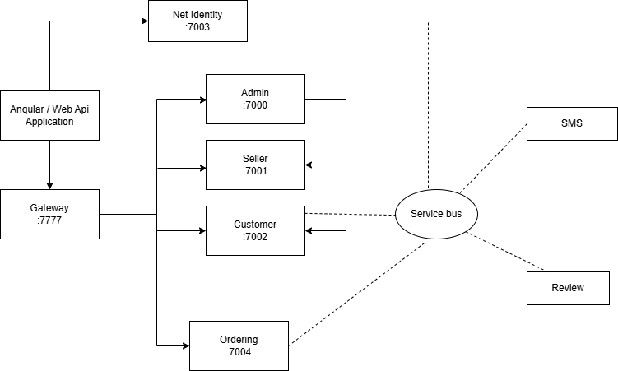

* **April 05, April 07**

**Agenda :** Class Diagram

Created separate Class diagram for each Microaservices

* **April 08, April 09**

**Agenda** : Microservices

Started working on the Microservices and Created one. [AuthAPi].

* **April 05, 2025**

**Agenda** : Designing UseCase diagram and Class Diagram.

* **UseCase Diagram**

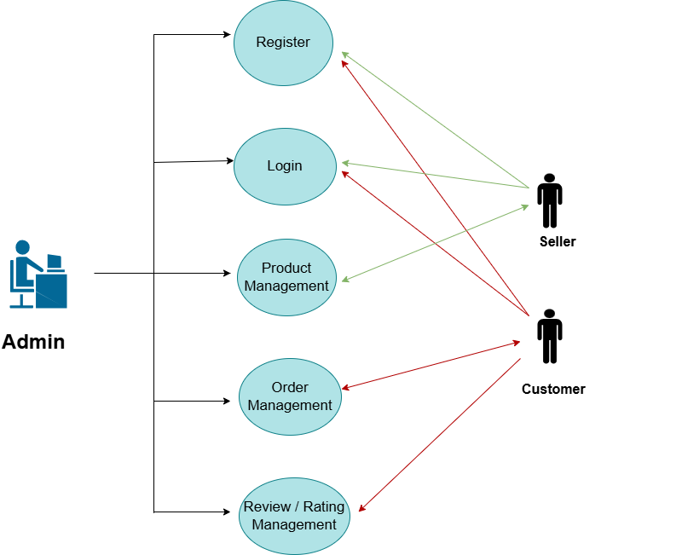

* **Class Diagram**